Exercise 1- Cherry-Picking Diagram created with drawio and screenshotted
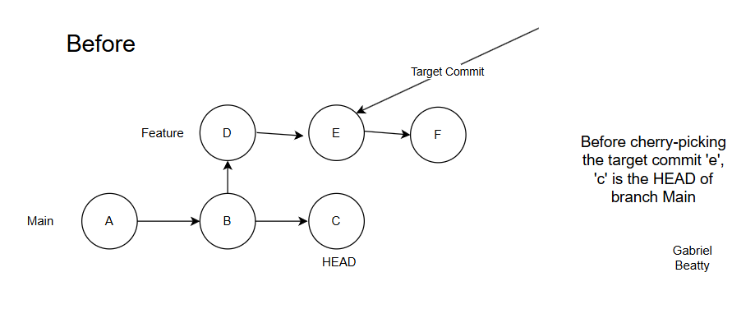
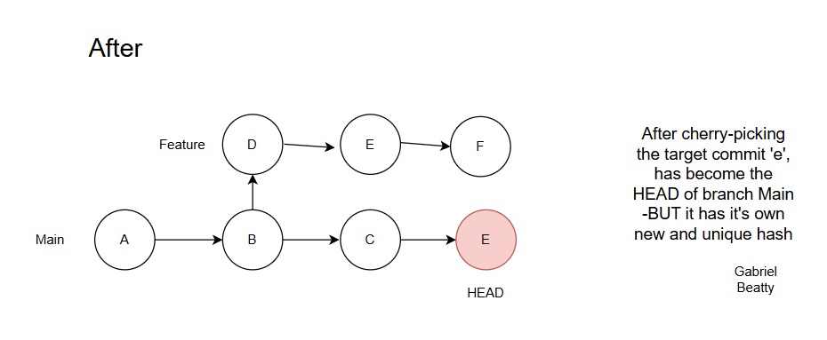
Use Cases | Disadvantages
Hotfix – if you need to fix a critical bug quickly and don’t want to import raw code in a full merge. | You end up with the same fix having multiple commits on different branches with different hashes.
You can copy a fix from a later version retroactively into a legacy version. This is called Backport Patching. | It hides the full history so you can’t follow what a developer was thinking.
If you have accidentally made a commit on the Main branch that should be on a Feature branch… you can fix that mistake by first cherry-picking the commit onto the feature branch and then doing a set of the HEAD of the Main branch. | Can create complex merge problems in the future. Can make things a little messy.

Exercise 2- Clean command
- Preview the changes-
git clean -n [-n or –dry-run will allow user to preview what will be deleted.

- Remove Untracked Files-
git clean -f [-f is required to force git to perform the deletion unless you set the clean.requireforce variable to false.][deletes untracked files only within the current directory.]
- Remove Untracked Directories-
git clean -fd [deletes both untracked files and subdirectories. Will delete entire folders if untracked.]

- Interactively Remove Files-
git clean -i [opens an interface to assist in choosing deletion through individual choice or pattern]

- Remove Ignored Files-
git clean -fx [this lowercase ‘x’ version will delete ignored files including the ones ignored by your .gitignore]

git clean -fX [this uppercase ‘X’ version will delete ignored files but will keep the standard untracked files]

